A PROJECT REPORT



ON

**MENTAL HEALTH PREDICTION IN STUDENTS**

Submitted to

KIIT Deemed to be University

In Partial Fulfillment of the Requirement for the Award

BACHELOR’S DEGREE IN COMPUTER SCIENCE &

ENGINEERING

By

AKASH TIWARI - 1706010

PRABHAT ROSHAN - 1706430

RISHAV SUBEDAR - 1706440

SATYAM PATEL - 1706452

SAYAN ROY - 1706453

SHREYA BAKSHI - 1706458

SOUMYA DARSHINI KAR - 1706463

UNDER THE GUIDANCE OF

**PROF: JUNALI JASMINE**

SCHOOL OF COMPUTER ENGINEERING

**KALINGA INSTITUTE OF INDUSTRIAL TECHNOLOGY** BHUBANESWAR, ODISHA – 751024 FEBRUARY 2021

**KIIT Deemed to be University**

**School of Computer Engineering**

**Bhubaneswar, ODISHA 751024**

**CERTIFICATE**

This is to certify that the project entitled

**Prediction of Mental Health in Students**

Submitted by:

**AKASH TIWARI - 1706010**

**PRABHAT ROSHAN - 1706430**

**RISHAV SUBEDAR - 1706440**

**SATYAM PATEL - 1706452**

**SAYAN ROY - 1706453**

**SHREYA BAKSHI - 1706458**

**SOUMYA DARSHINI KAR - 1706463**

is a record of Bonafide work carried out by them, in the partial fulfillment of the requirement for the award of Degree of Bachelor of Engineering (Computer Science & Engineering ) at KIIT Deemed to be university, Bhubaneswar. This work is done during year 2019-2020, under our guidance.



Date: 6 / 06 / 2020 **Prof. Junali Jasmine**

**Project Guide**

**Project Guide**



**ACKNOWLEDGEMENTS**

We are profoundly grateful to Prof. **Junali Jasmine** for his expert guidance and encouragement throughout to see that this project rights its target since its commencement to its completion. The work is a team effort minus which the completion of this project was not possible.

**AKASH TIWARI - 1706010**

**PRABHAT ROSHAN - 1706430**

**RISHAV SUBEDAR - 1706440**

**SATYAM PATEL - 1706452**

**SAYAN ROY - 1706453**

**SHREYA BAKSHI - 1706458**

**SOUMYA DARSHINI KAR - 1706463**

**ABSTRACT**

Behavioral health treatment is grounded in the medical model with language of deficits and problems, rather than resources and strengths. With developments in the field of positive psychology, re-focusing on well-being rather than illness is possible. Studies have shown that mental health problems can negatively influence academic performance as well as personality disorders. Fortunately, positive mental health can serve as a buffer against mental health problems. This paper makes use of Mental Health dataset available in the source repository.

1

**TABLE OF CONTENTS**

|  |  |  |  |
| --- | --- | --- | --- |
|  | Page No | | |
| Abstract | | : | 1 |
| Table of Contents | | : | 2-3 |
| List of Figures | | : | 3 |
| List of Tables | | : | 3 |
| List of symbols/ abbreviations | | : |  |
| List of Photographs | | : |  |
|  | | : |  |
| CHAPTER 1: INTRODUCTION | | : | 4-6 |
| 1.1 The Instigation Process | |  | 4-5 |
|  | 1.1.1 Dataset Exploration | : | 5 |
|  | 1.1.2 Technologies Used | : | 5 |
| 1.2 Proposed Working | | : | 5-6 |
|  | 1.2.1 Flowchart | : | 6 |
|  | 1.2.2 The working model | : | 6 |
|  | 1.2.3 Limitations : 6 | | |
| CHAPTER 2: BACKGROUND/BASIC CONCEPTS | | : | 7-8 |
| 2.1 Machine Learning Procedure | | : | 7 |
|  | 2.1.1 The Steps Involved | : |  |
|  | 2.1.2 Classification Algorithms used | : |  |
| 2.2 Result Algorithm used | | : |  |
|  | 2.2.1 Analyzing the Output | : | 8 |
|  | 2.2.2 Confusion Matrix : 8 | | |
| CHAPTER3: PROJECT ANALYSIS/ PROJECT IMPLEMENTATION | | : | 9- |
| 3.1 | Importing the libraries | : | 9 |
| 3.2 | Loading the data | : | 9 |
| 3.3 | Getting the shape of the data | : | 9 |
| 3.4  3.5  3.6  3.7  3.8  3.9 | Getting the description of the data : 10  Checking the null values in the data : 11  Dropping analyzed null values : 11  Converting categorical data into numeric values : 11  Rearranging of columns : 12  Removal of NaN : 12 | | |
| CHAPTER 4: RESULTS AND DISCUSSION | | : |  |
| 4.1 | Values obtained from Confusion Matrix from different Classification Algorithms | : |  |
| 4.2 | Analysis of Machine Learning Algorithms | : |  |
|  |  | | |
| CHAPTER 5: CONCLUSION & FURTHER WORK | | : |  |
|  |  | | |
| REFERENCES | 21-24 | : |  |

**LIST OF FIGURES**

|  |  |  |
| --- | --- | --- |
| **Figure ID** | **Figure Title** | **Page** |
| 1.1 | Dataset Snippet | 5 |
| 1.2 | Experiment Flowchart | 6 |
| 3.1 | Code Snippet | 9 |
| 3.2 | Code Snippet | 9 |
| 3.3 | Code Snippet | 9 |
| 3.4 | Code Snippet | 9 |
| 3.5 | Code Snippet | 10 |
| 3.6 | Code Snippet | 10 |
| 3.7 | Code Snippet | 11 |
| 3.8 | Code Snippet | 11 |
| 3.9 | Code Snippet | 12 |
| 3.10 | Code Snippet | 12 |
| 3.11 | Code Snippet |  |
| 3.12 | Code Snippet |  |
| 3.13 | Code Snippet |  |
| 3.14 | Code Snippet |  |

**LIST OF TABLES**

|  |  |  |
| --- | --- | --- |
| **Table ID** | **Table Title** | **Page** |
|  |  |  |
|  |  |  |
|  |  |  |
|  |  |  |
|  |  |  |
|  |  |  |
|  |  |  |

**CHAPTER 1**

**INTRODUCTION**

1.1 The Instigation Process

Mental health is a state of well-being in which a person understands his or her own abilities, can cope with the normal stresses of life, can work productively and fruitfully, and is able to make a contribution to his or her community.

Both physical and mental health are the result of a complex interplay between many individual and environmental factors, including:

* family history of illness and disease/genetics
* lifestyle and health behaviours (e.g., smoking, exercise, substance use)
* levels of personal and workplace stress
* exposure to toxins
* exposure to trauma
* personal life circumstances and history
* access to supports (e.g., timely healthcare, social supports)
* coping skills

When the demands placed on someone exceed their resources and coping abilities, their mental health will be negatively affected. Two examples of common demands are: i) working long hours under difficult circumstances, and ii) caring for a chronically ill relative. Economic hardship, unemployment, underemployment and poverty also have the potential to harm mental health.

Mental illness is a recognized, medically diagnosable illness that results in the significant impairment of an individual's cognitive, affective or relational abilities. Mental disorders result from biological, developmental and/or psychosocial factors and can be managed using approaches comparable to those applied to physical disease.

Records of large set of medical data created by medical experts are available for analysing and extracting valuable knowledge from it. Machine Learning techniques are the means of extracting valuable and hidden information from the large amount of data available. Mostly the medical database consists of discrete information. Hence, decision making using discrete data becomes complex and tough task. Machine Learning (ML) which is subfield of data mining handles large scale well-formatted dataset efficiently. In the medical field, machine learning can be used for diagnosis, detection and prediction of various diseases. The main goal of this paper is to provide a tool for doctors to detect mental diseases at an early stage. This in turn will help to provide effective treatment to patients and avoid severe consequences. ML plays a very important role to detect the hidden discrete patterns and thereby analyse the given data. After analysis of data ML techniques help in heart disease prediction and early diagnosis. This paper presents performance analysis of various ML techniques such as Logistic Regression and Support Vector Machine for predicting mental disease at an early stage and hence prevent suicidal tendencies in the person.

4

* + 1. Dataset Exploration

The dataset contains 286 rows and 50 columns. The data was collected from several domestic and international students who were currently studying in Ritsumeikan Asia Pacifific University and were subjected to various General Health Help-Seeking Questionnaire and Patient Health Questionnaire based on Acculturative Stress Scale for International Students and Social Connectedness Scale. There were certain missing values which have been dealt and handled well. This dataset can be used by researchers and people related to medical fields. (Source: http://www.mdpi.com/2306-5729/4/3/124/s1.)

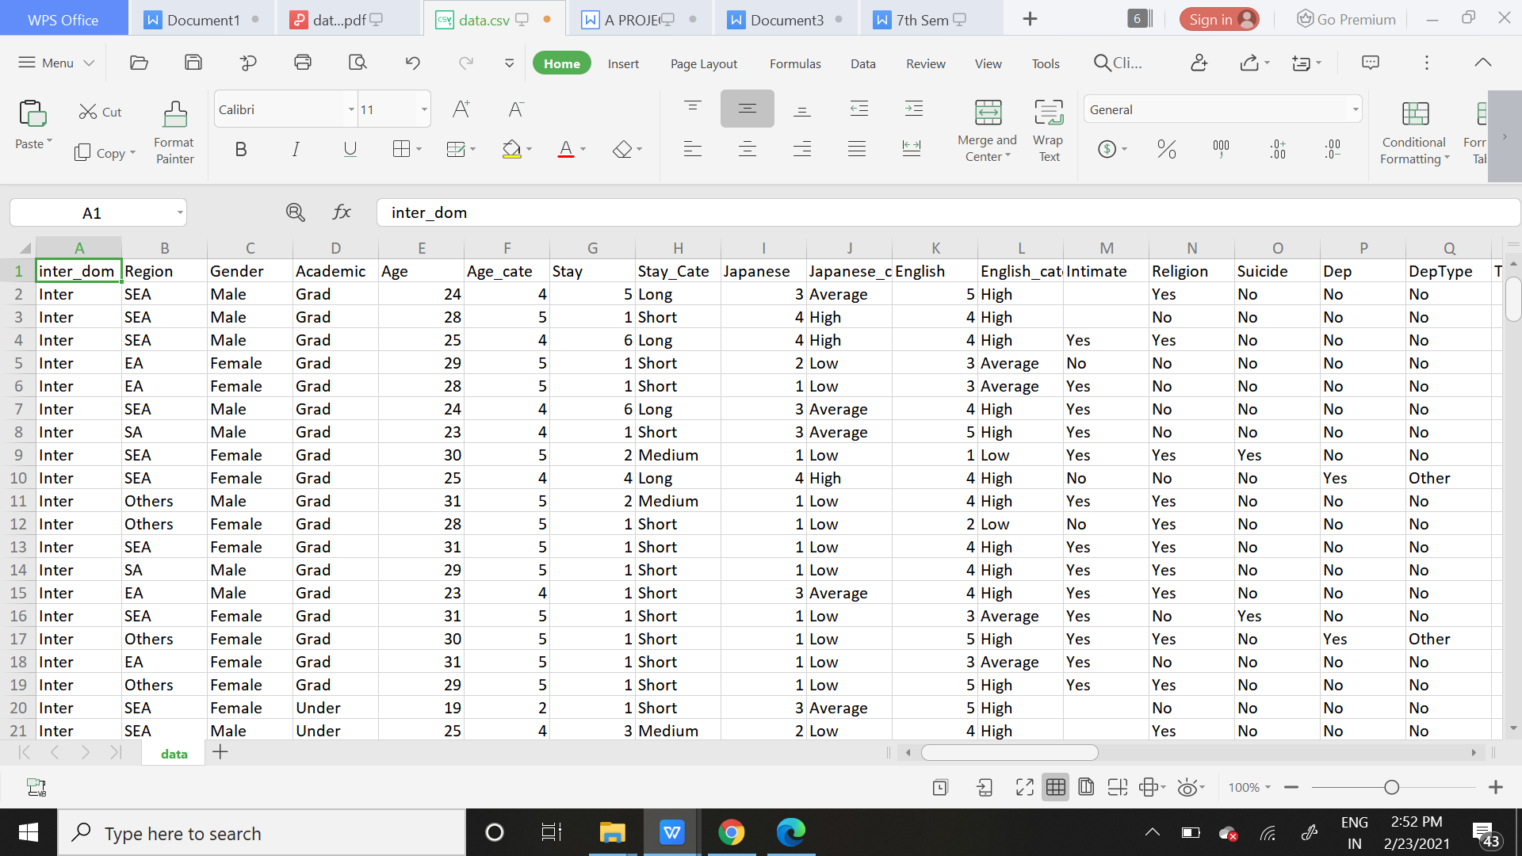

*Fig 1.1*

* + 1. Technology Used

Our experiment is a Supervised Machine Learning concept where the input data as well as the output data (that is the target variable) both are given. We get our data from the source and then cleaned it by removing unwanted features. We have used Feature selection procedures in our work and then scaled it as per our requirement. We later spitted the training and testing data and developed a model using training data and applied the result on testing data. Our work yielded precedented results.

We used Python 3.8 in Google Collab IDE for our experiment.

* 1. Proposed Working

The proposed work predicts whether a person can attempt suicide or not depending upon several mental illness constraints by exploring the classification algorithms and does performance analysis. The objective of this study is to effectively check if the patient suffers from mental depressions or other disorders. The health professional measures the various parameters from the patient's health report and the data is fed into model which in turn says if the person is probable towards attempting suicide or not.

5

1.2.1 Flowchart



Our experiment is set to follow such a flowchart:

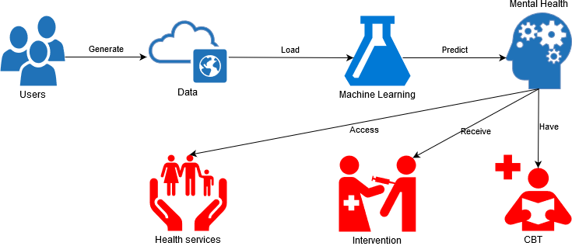

*Fig 1.2*

1.2.2 The Working Model

Our proposed model can be implemented in a Basel Screening Instrument for Psychosis (BSIP). It is a device which detects the most important risk factors responsiblefor mental disorders or suicidal thoughts. Hence forth the architecture of this device can be inspired from our model and help detect mental illness in students.

1.2.3 Limitations

1. Our experiment is a theoretical practise. So practical application needs to be implemented based on the working environment.
2. The input values need re scaling to achieve results. Higher number of features may not be possible to be scaled.

3. The experiment is based on hit and trial method using different algorithms. Hence forth in a particular vicinity the model may not give higher accuracy.

6

**CHAPTER 2**

**BACKGROUND/BASIC CONCEPTS**

Our experiment is a **Supervised Machine Learning Problem** where the inputs and the target variable both are given. The data and associated target responses that can consist of numeric values or string labels, such as classes or tags, in order to later predict the correct response when posed with new examples comes under the category of Supervised learning.

* + 1. The Steps Involved:-

**Step 1: Collecting the data -** The quantity & quality of your data dictate how accurate our model is. We collected data from kaggle.

**Step 2: Data Preparation -** Here we wrangle data and prepare it for training. We also clean that which may require it (remove duplicates, correct errors, deal with missing values, normalization, data type conversions, etc.). We can also randomize data, which erases the effects of the particular order in which we collected and/or otherwise prepared our data. We too can visualize data to help detect relevant relationships between variables or class imbalances (bias alert!), or perform other exploratory analysis and split into training and evaluation sets.

**Step 3: Choosing a model -** Different algorithms are for different tasks; choose the right one.

**Step 4: Train the Model -** The goal of training is to answer a question or make a prediction correctly as often as possible. Each iteration of process is a training step.

**Step 5: Evaluate the Model -** Uses some metric or combination of metrics to "measure" objective performance of model. Test the model against previously unseen data. This unseen data is meant to be somewhat representative of model performance in the real world, but still helps tune the model (as opposed to test data, which does not). Good train/eval split? 80/20, 70/30, or similar, depending on domain, data availability, dataset particulars, etc.

**Step 6: Parameter Tuning -** This step refers to hyperparameter tuning, which is an "artform" as opposed to science. The tune model parameters improve performance. Simple model hyperparameters may include: number of training steps, learning rate, initialization values and distribution, etc.

**Step 7: Making Predictions -** Using further (test set) data which have, until this point, been withheld from the model (and for which class labels are known), are used to test the model; a better approximation of how the model will perform in the real world.

7

2.1.2 Classification Algorithms used:



* 1. Results Algorithm used:

**2.2.1 Analyzing the output:**

In the experiment the pre-processed dataset is used to carry out the experiments and the above mentioned algorithms are explored and applied. The above mentioned performance metrics are obtained using the confusion matrix. Confusion Matrix describes the performance of the model.

**2.2.2 Confusion Matrix:**

A confusion matrix is a summary of prediction results on a classification problem. The number of correct and incorrect predictions are summarized with count values and broken down by each class. This is the key to the confusion matrix. It gives you insight not only into the errors being made by your classifier but more importantly the types of errors that are being made. It is this breakdown that overcomes the limitation of using classification accuracy alone.

Precision = (TP) / (TP +FP ) (2)

Recall = (TP) / (TP+FN) (3)

F Measure =(2 * Precision * Recall) / (Precision +Recall)

TP True positive: the patient has the disease and the test is positive.

FP False positive: the patient does not have the disease but the test is positive.

TN True negative: the patient does not have the disease and the test is negative.

FN False negative: the patient has the disease but the test is negative.

8

**CHAPTER 3**

**PROJECT ANALYSIS/ PROJECT IMPLEMENTATION**

3.1 Importing the Libraries

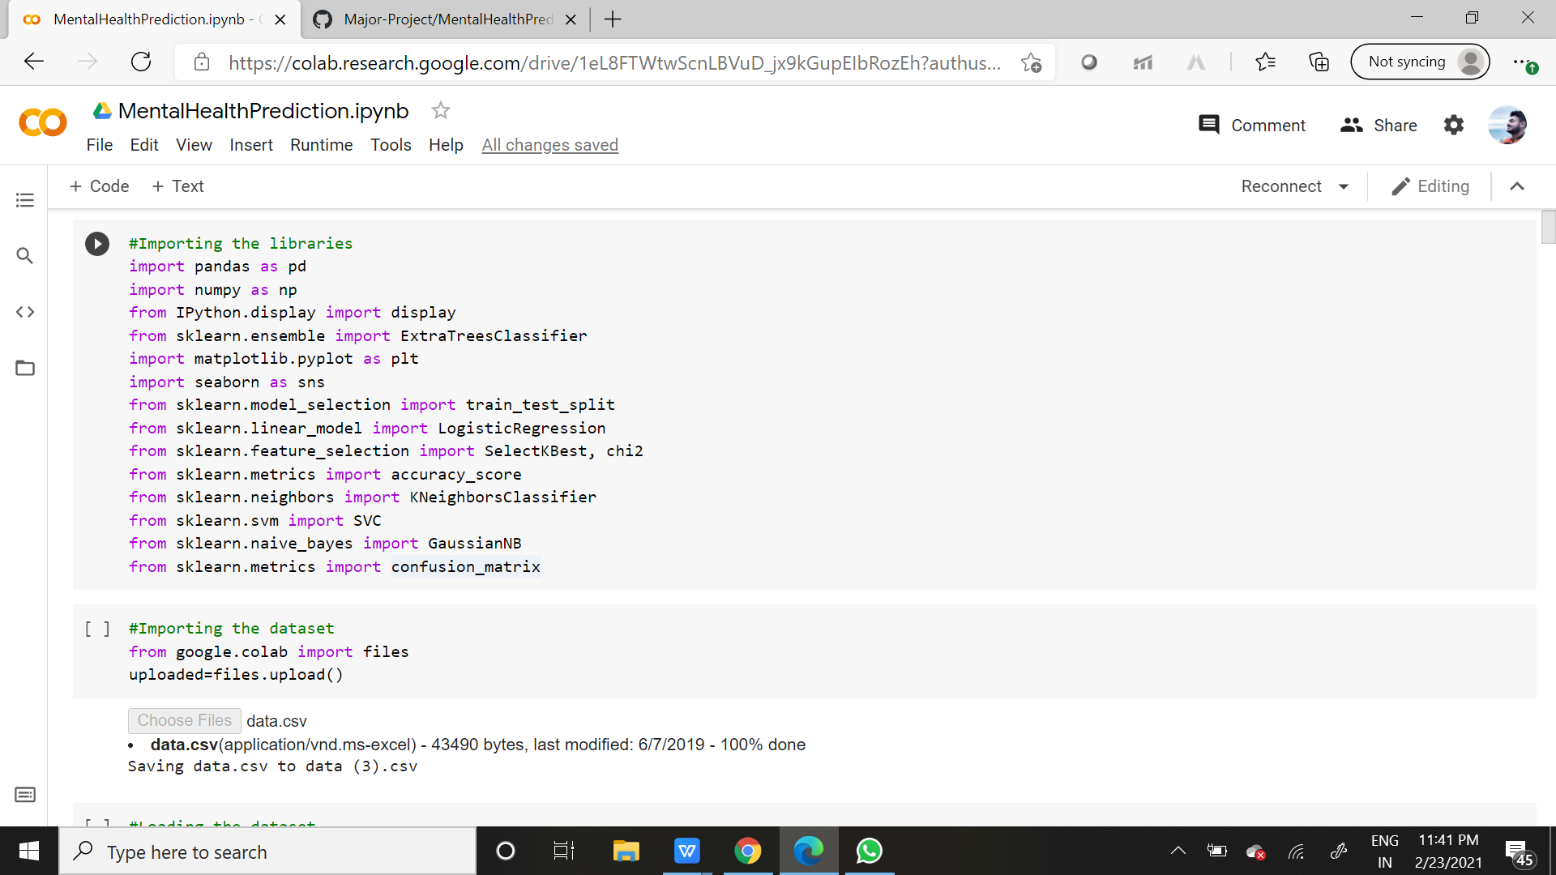

*Fig 3.1*

3.2 Importing the dataset and Loading the data

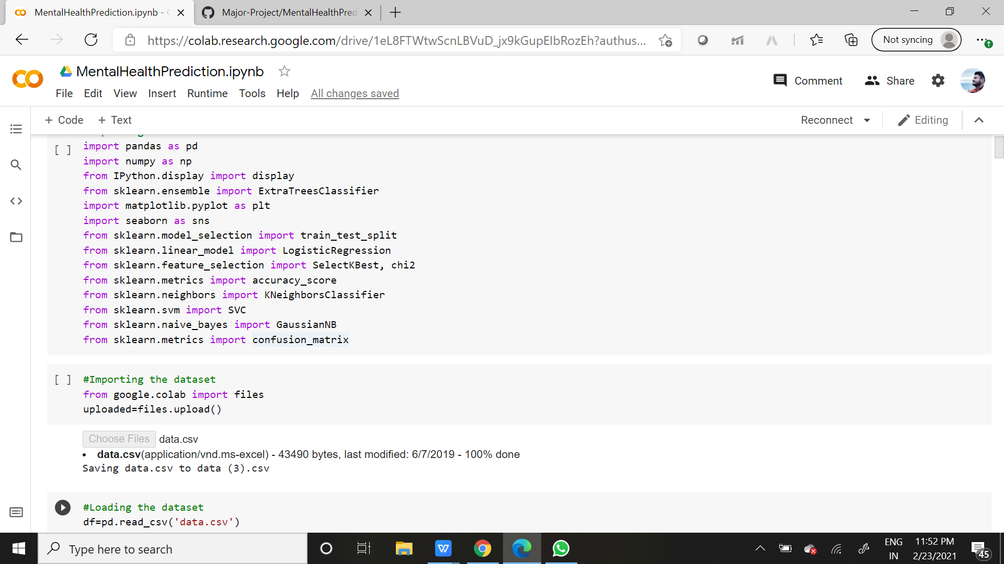

*Fig 3.2*

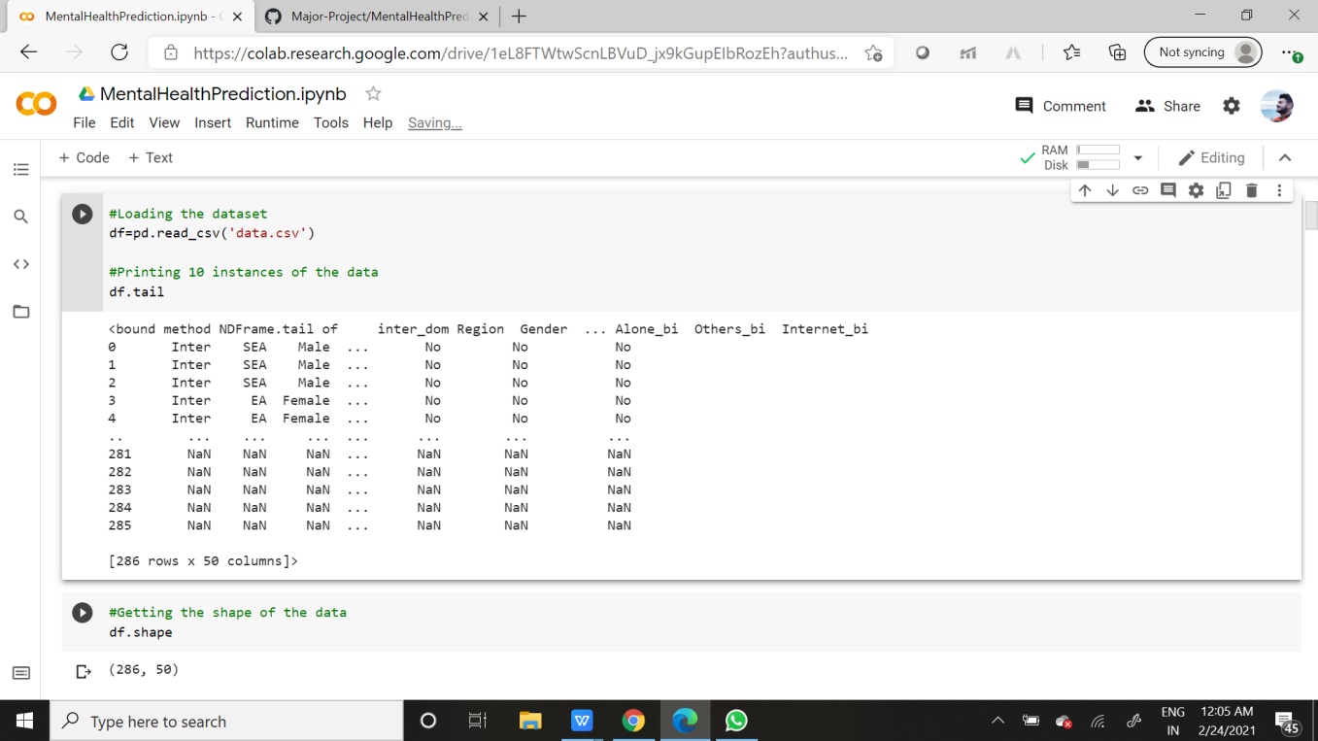

*Fig 3.3*

3.3 Getting the shape of the data

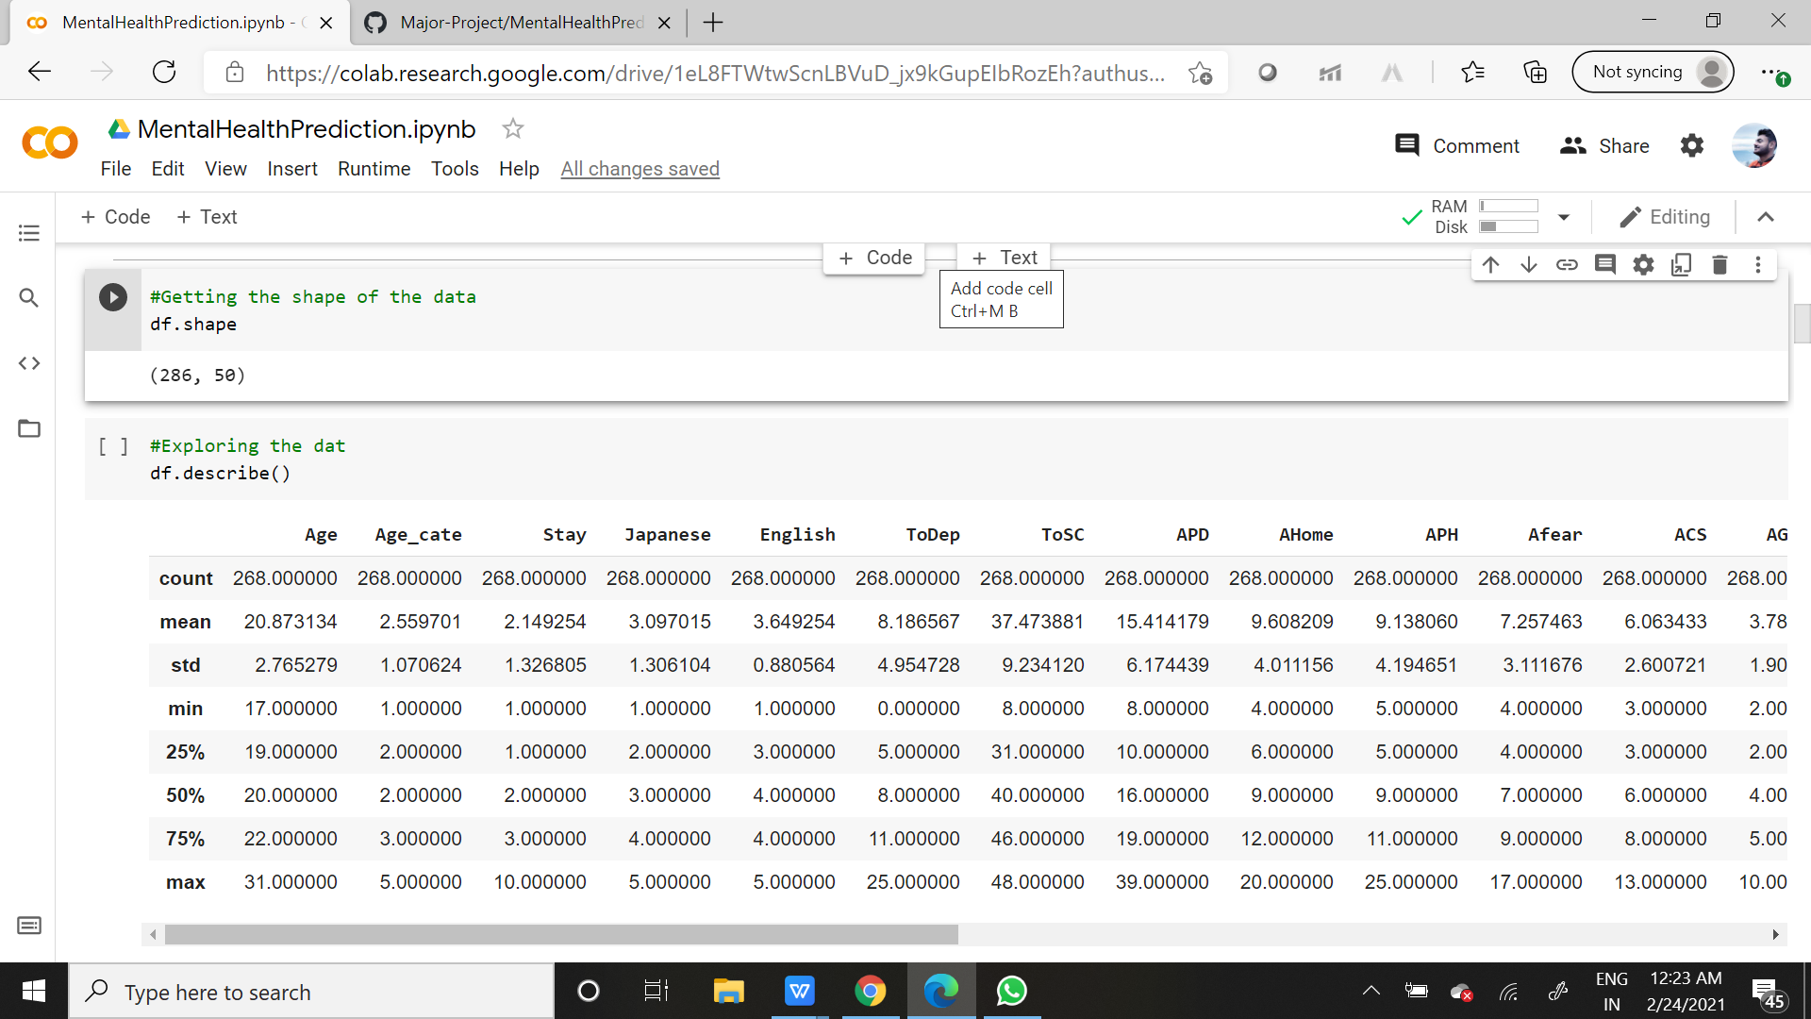

*Fig 3.4*

9

3.4 Getting the description of the data

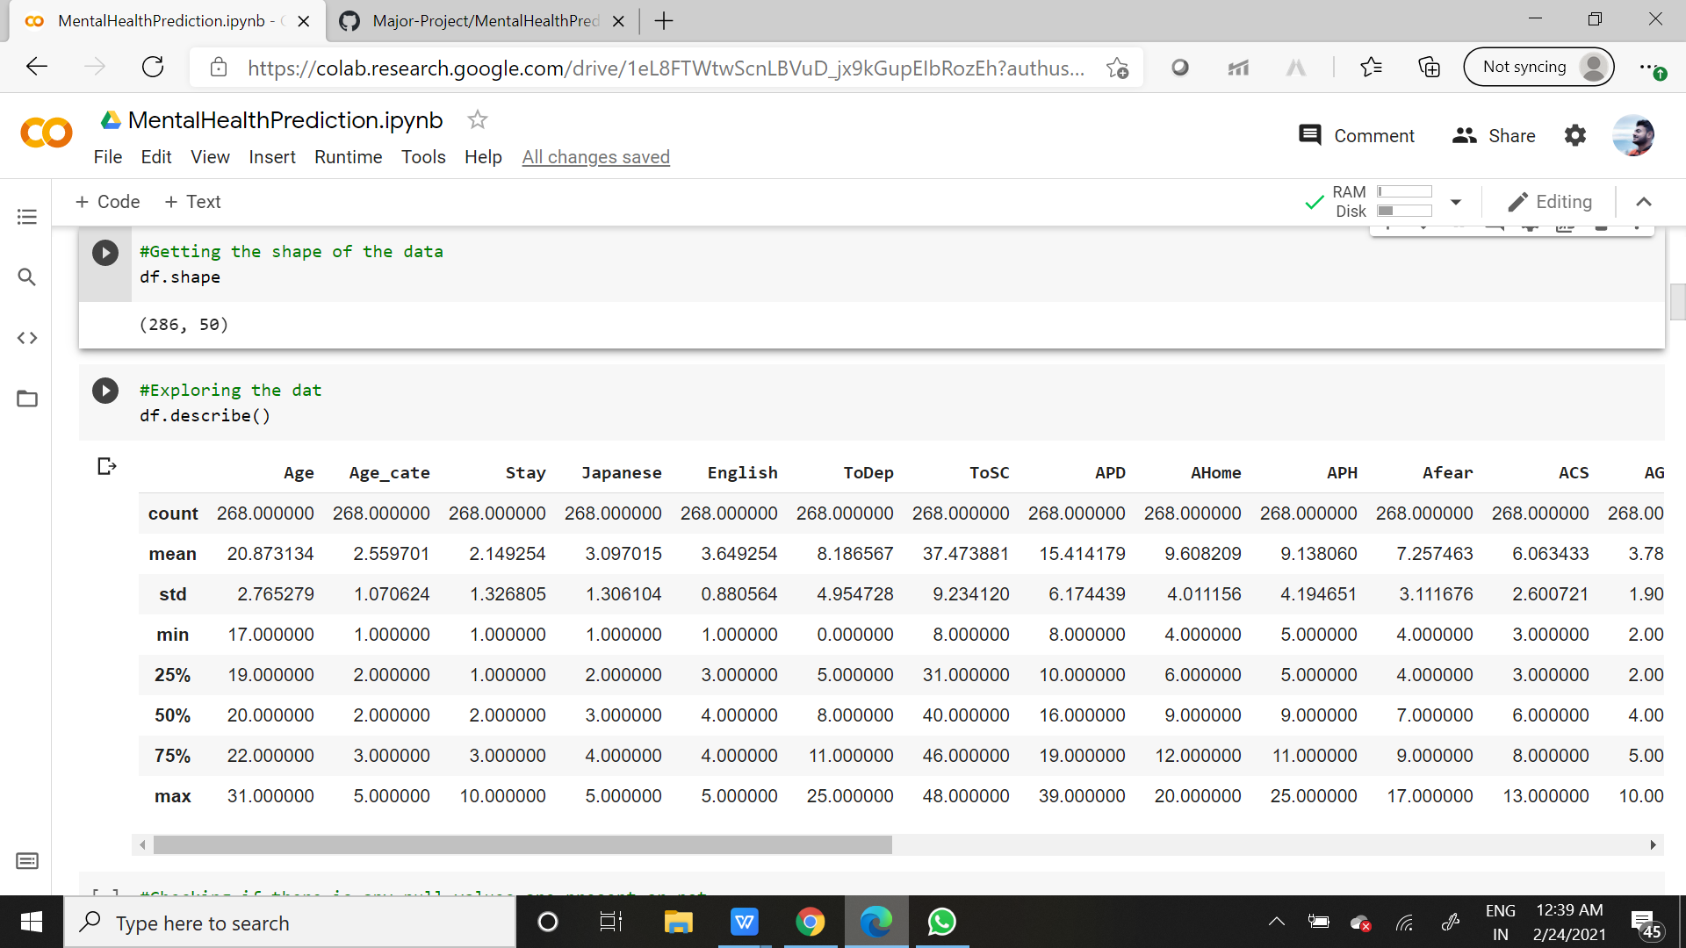

*Fig 3.5*

3.5 Checking Null Values in the data

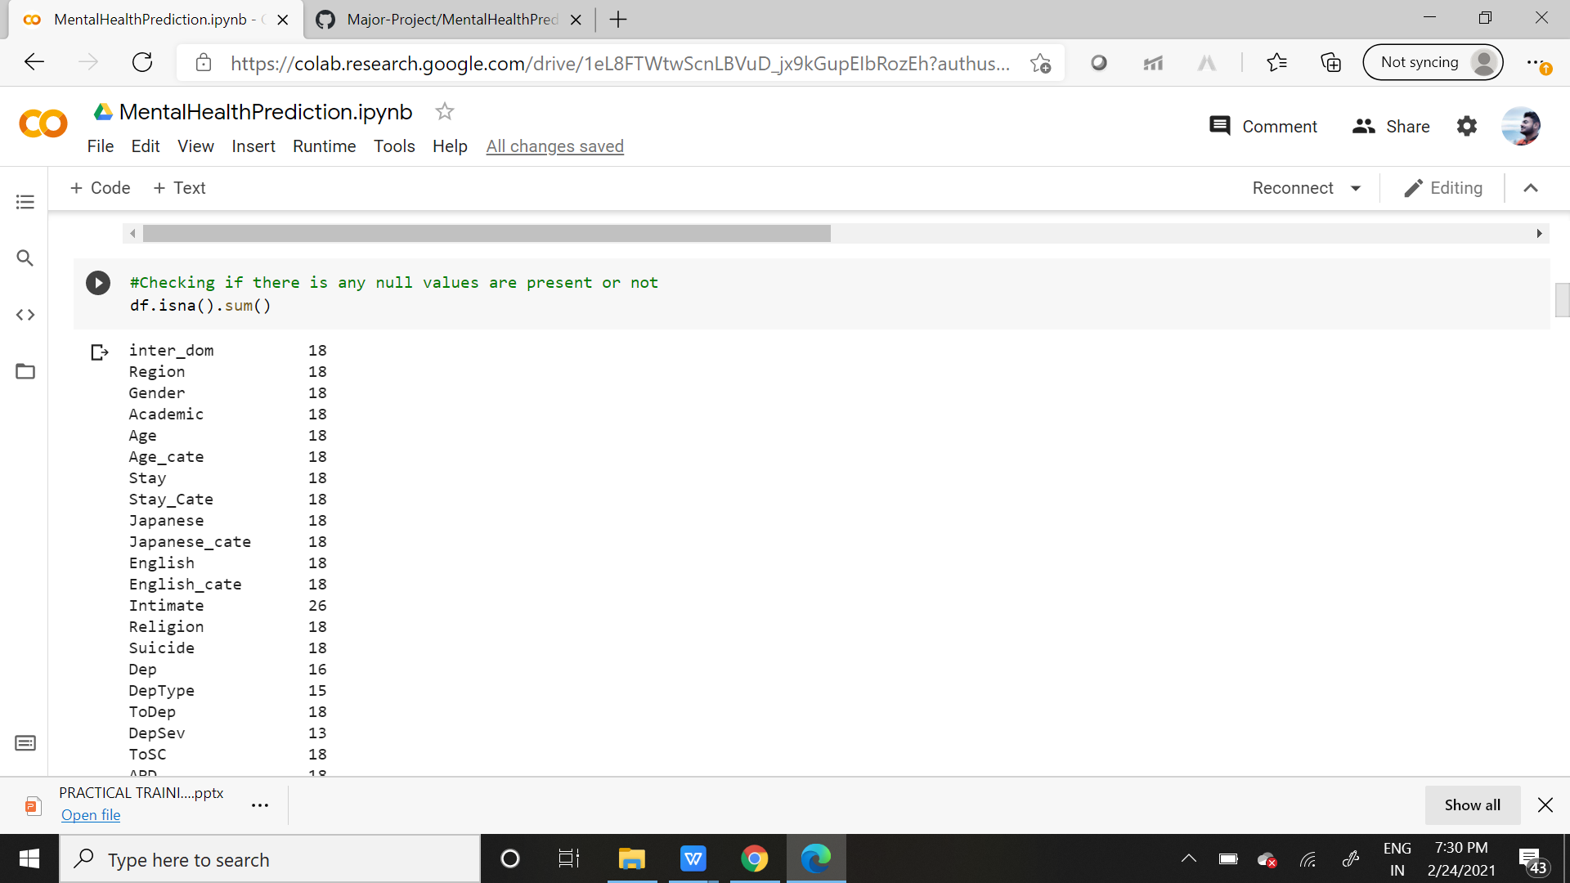

*Fig 3.6*

Analysis Assumption

In the above exploration, we found out that the number of missing values in most cases are more than 5% of the data, that is if we do 5% of 286 = 14.3, which exceeds the limit of our missing values in most cases. Moreover its Multivariate Analysis, so we need to keep in account all the columns which are contributing to the analysis and hence forth we can't drop those columns. However we can drop which are less than that.

**10**

3.6 Dropping the above mentioned Null Values:

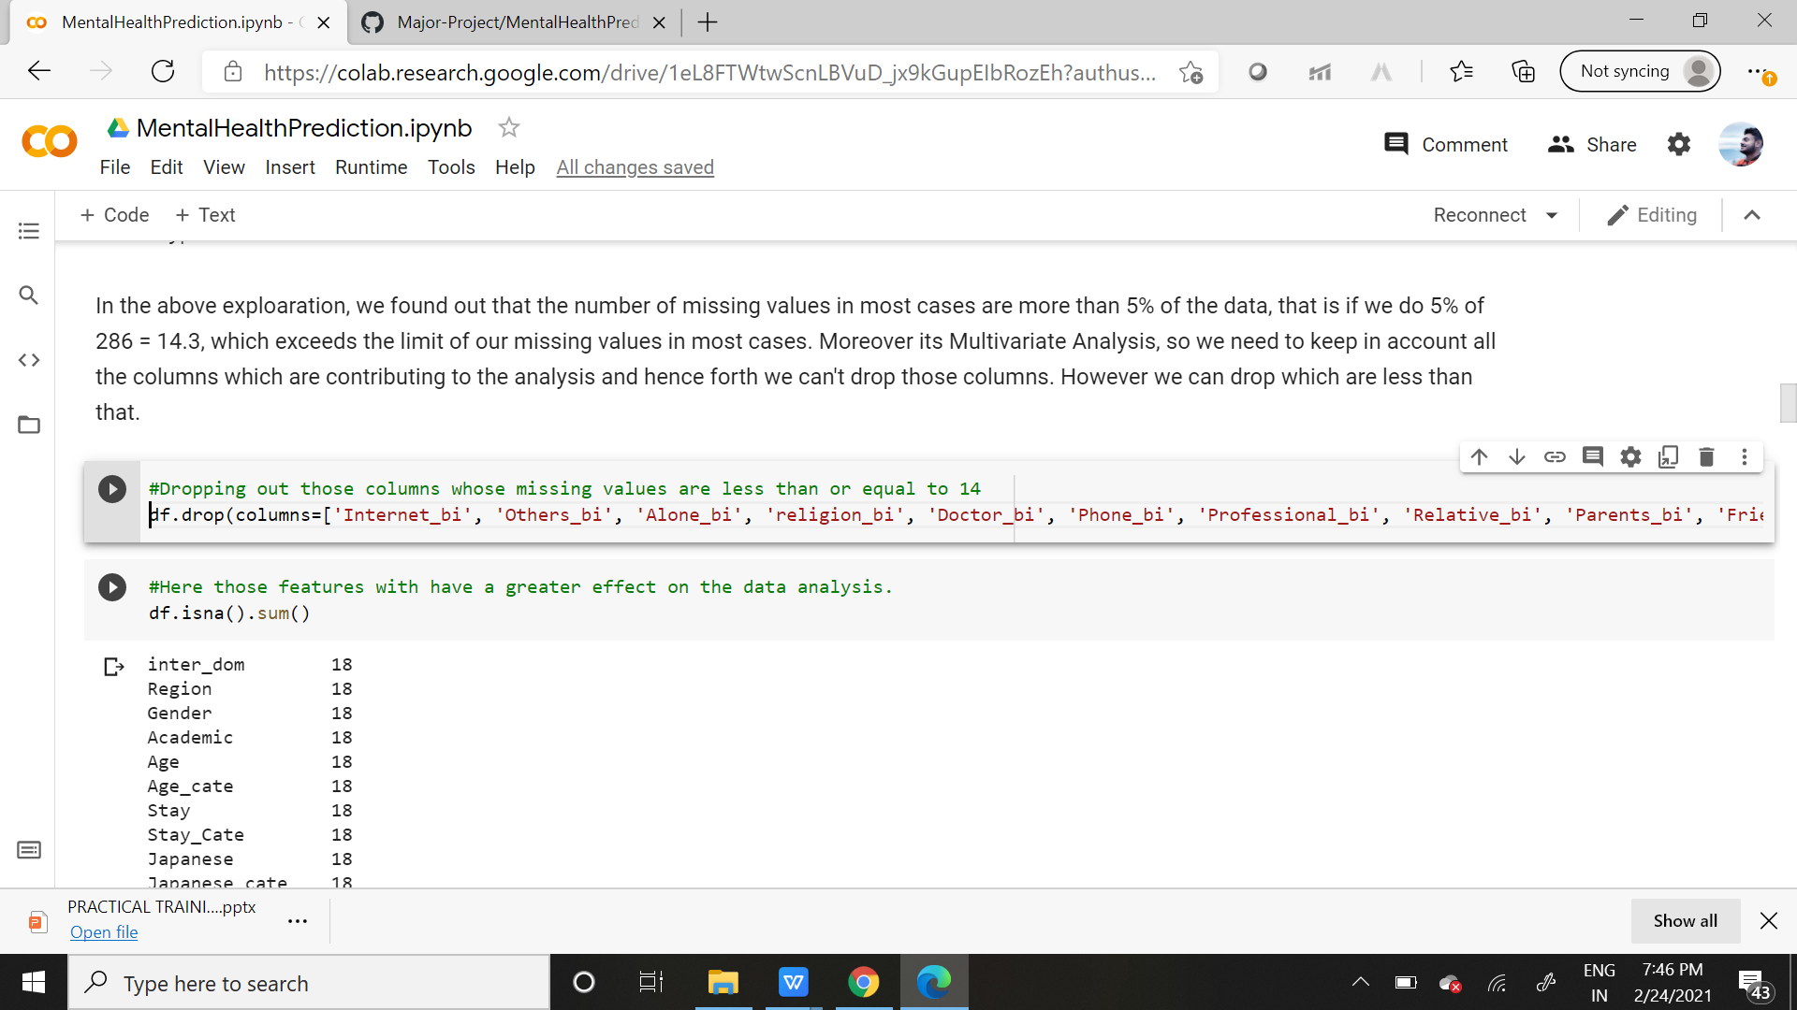



*Fig 3.7*

Analysis Assumption

In the above exploration after removing the above missing values, we are left with those missing values which may have an higher impact on our data analysis. However many of this data are categorical in nature and hence forth we need to convert them into numerical forms for further analysis. Here we converted many columns such as ‘inter_dom’, ‘Region’, ‘Gender’, ‘Academic’, etc.

3.7 Conversion of categorical data:

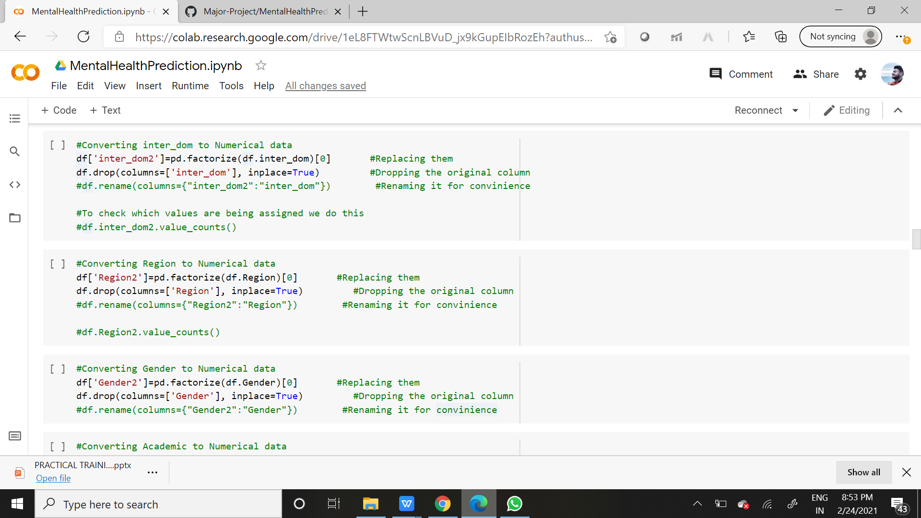

*Fig 3.8*

3.8 Rearranging of columns:

Analysis Assumption

In the above exploration, when we convert our categorical data our columns are bound to get re-shuffled and the new numerical columns formed from above gets added after the previous indexed 50th column, one after the other. So in order to get the proper view, we increase the default view scope in our IDE, which will further help us in analysis.

11

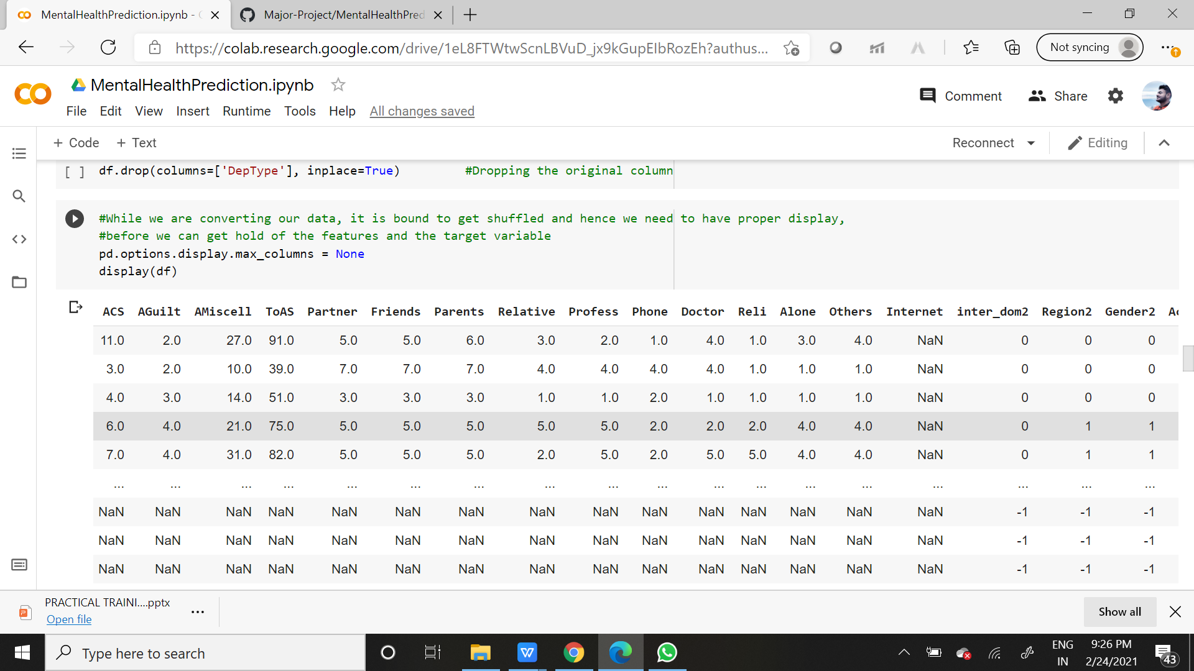

*Fig 3.9*

3.9 Removal of NaN:

Analysis Assumption

In the above exploration after converting our categorical data into numerical data, the portion of missing values is replaced with NaN. NaN implies ‘Not a Number’. For analysis purpose, NaN can be replaced with 0, or the average values of all the data in the column. We presumed to replace it with 0 and carry forward on building the model. It may happen that our assumption is wrong, which may be possible when the accuracy of our model turns out to be below expectation. But for now we stick to 0 and move on.

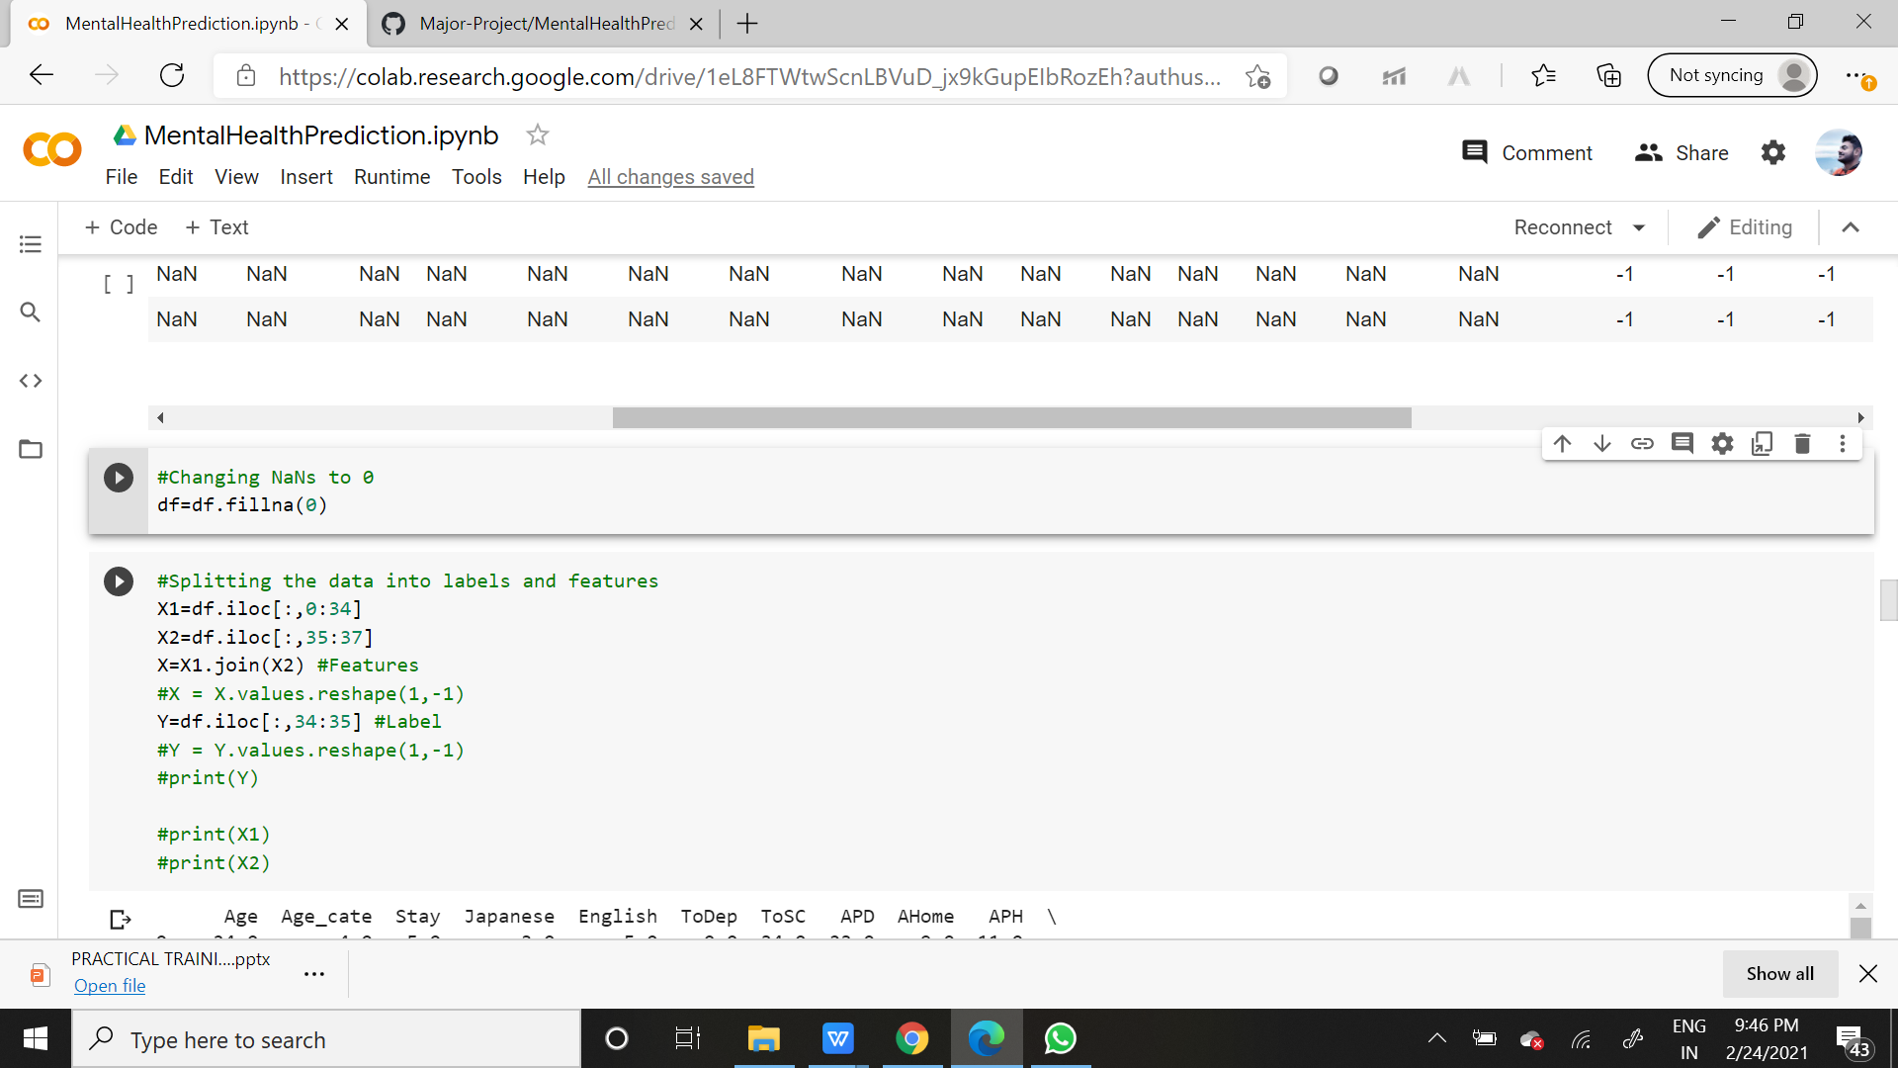

*Fig 3.10*

12

**LITERATURE REVIEW**

1. **Ibrahim, A. K., Kelly, S. J., Adams, C. E., & Glazebrook, C. (2013). A systematic review of studies of depression prevalence in university students. *Journal of psychiatric research*, *47*(3), 391-400.**

This study was done to suggest that there is a strong evidence that university students are at higher risk of depression, despite being a socially advantaged population. This review has two main objectives: (I) to identify studies reporting on rates of depression among university students (II) to examine the hypothesis that there is an increase in the rates of depression among undergraduate university students.

**METHODOLOGY:**

1. PubMed, PsycINFO, BioMed Central and Medline were searched to identify studies published between 1990 and 2010 reporting on depression prevalence among university students.
2. Searches used a combination of the terms depression, depressive symptoms, depressive disorders, prevalence, university students, college students, undergraduate students, adolescents and/or young adults. Studies were evaluated with a quality rating.

As sample size and response rate are crucial for any prevalence study, special attention should be drawn to their determination and reporting.

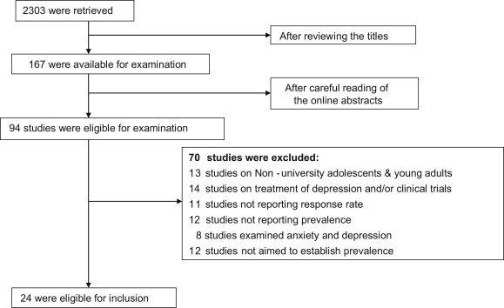



**PROS:**

1. This study encompasses several nested cross-sectional studies that include comparative general population samples. Hence is a well-validated and reliable tool for depression screening designed for university students.
2. The study also found wide variability in inclusion and exclusion criteria and tools for diagnosis of depression and determination of its severity.

**CONS:**

1. The major limitation was the possibility of missing studies not directly reporting on depressive prevalence (i.e. studies examining the prevalence of general distress and using measures that screen for depression as one of the elements of general distress e.g. the General Health Questionnaire of Symptom Checklist (SCL-90)).
2. The co-morbidity of anxiety and depression may lead to over-estimation of the prevalence rates in the studied papers.



1. The average prevalence of depression in the current review (30.6%) may have been attenuated by including some studies that reporting only rates of major depressive disorder rather than minor depressive states.
2. A limited number of studies were included in this review as many studies reported the prevalence of depression prevalence but did not report a response rate. This is important because the lower the response rate, the less valid (for both external and internal validity) the study as differences between non-respondents and respondents may exist (non-response bias) in other perspectives than just their willingness to take part in a survey ([Denscombe, 2008](https://www.sciencedirect.com/science/article/pii/S0022395612003573" \l "bib16), [2009](https://www.sciencedirect.com/science/article/pii/S0022395612003573" \l "bib17)).

**CONCLUSION:**

The data was read extensively and an agreed quality assessment instrument for epidemiological prevalence studies was adapted from Parker and colleagues ([Parker et al., 2008](https://www.sciencedirect.com/science/article/pii/S0022395612003573" \l "bib64)). Articles scored one point for each of the following quality markers:

1. the target population was defined clearly,
2. complete, random or consecutive recruitment,
3. the targeted sample is representative or the report presents evidence that the results can be generalized to the general undergraduate population,

(4)the response rate was equal or greater than 70%,

(5) the scale used is a validated measure of depression with valid cut-offs for classification of depression, (6) the sample size is adequate with a minimum sample size of 300 ([Loney et al., 1998](https://www.sciencedirect.com/science/article/pii/S0022395612003573" \l "bib47)),

(7) the confidence intervals (CI) or standard error (SE) are reported. The last two quality criteria were added because the larger the sample, the more precise the results are ([Strachan, 1997](https://www.sciencedirect.com/science/article/pii/S0022395612003573" \l "bib76)).

Additionally, CI and SE are important for the reliability assessment of the outcome of prevalence studies. In the study results either CI or SE should be computed and always reported The results suggest that university students experience rates of depression that are substantially higher than those found in the general population. Twenty-four articles were identified that met the inclusion and exclusion criteria. Reported prevalence rates ranged from 10% to 85% with a weighted mean prevalence of 30.6%.

1. **Sandhu, D. S., & Asrabadi, B. R. (1994). Development of an acculturative stress scale for international students: Preliminary findings. *Psychological reports*, *75*(1), 435-448.**

This paper gives the Description of the development and testing of a new 36-item scale in Likert format and is designed to assess the acculturative stress of international students, includes ~erceived discrimination, homesickness, fear, guilt, perceived hatred, and stress due to change (cultural shock), identified as major contributing factors. The psychometric properties of this instrument and implications for use by mental health practitioners are also discussed in this paper.

**METHODOLOGY:**

1. The procedures used to analyze the data included correlation and factor analyses.
2. The SPSS' Release 3.0 for UNISYS large computers was used to perform all necessary computations.
3. Bartlett's test of sphericity was used to test the hypothesis that the population correlation matrix was an identity matrix.
4. The anti-image correlation (the negative of the partial correlation coefficient) supported the feasibility of using factor analysis.

The value of the test statistic for sphericity was *3678.84* with an associated significance level of p< *.00001.* Although this test was based on the assumption that data were sampled from a multivariate normal population, the value of the test statistic was large enough to overcome the lack of normality.

**PROS:**

1. This paper focuses on the pursuit of learning beyond indigenous boundaries.
2. This scale might be useful for practitioners to identify and assess the acculturative stress of foreign students and improvise special strategies to help them.
3. The researchers could also use this scale to compare the experiences of acculturative stress of foreign students of various ethnic groups and use that information to assess the efficacy of counseling strategies.
4. The scale also quantifies this acculturative stress which could facilitate opportunities for more empirical research.

**CONS:**

1. Apparently research conducted on the psychological problems of international students is isolated, sporadic, inconsistent, varied, and desultory in nature.
2. Most of the psychological problems of the international students have been conceptualized with very little supporting empirical data.

**CONCLUSION:**

The method of principal components extracted six factors accounting for 70.6% of the total explained variance. These factors with their eigenvalvalues, percentages of variance, and cumulative percentages. The total scores range from 36 to 180 on this scale. Higher scores are indicative of greater acculturative stress perceived by the subjects. The scores on six subscales can be computed by adding the individual scores on the relative items.

1. **Wei, M., Heppner, P. P., Mallen, M. J., Ku, T. Y., Liao, K. Y. H., Wu, T. F. (2007). Acculturative stress, perfectionism, years in the United States, and depression among Chinese international students. *Journal of Counseling Psychology*, *54*(4), 385.**

This study examined whether maladaptive perfectionism ( i.e.discrepancy between expectations and performance) and length of time in the United States moderated the association between acculturative stress and depression. Data were collected through online surveys from 189 Chinese international students from China and Taiwan attending a midwestern university.

**METHODOLOGY:**

1. We measured acculturative stress using the Acculturative Stress Scale for International Students (ASSIS; Sandhu & Asrabadi, 1994)
2. Maladaptive perfectionism was measured with the Discrepancy subscale of the Almost Perfect Scale—Revised (APS–R; Slaney et al., 2001).
3. Depression was assessed with the Center for Epidemiological Studies—Depression Scale (CES–D; Radloff, 1977).
4. we conducted one multivariate of analysis of variance to examine whether the main measures (acculturative stress, maladaptive perfectionism, and depression) varied in regards to sex, marital status, country of origin, and different language versions.
5. In addition, we examined whether there were interaction effects of sex, marital status, country of origin, and different language versions on the main variables.
6. A hierarchical regression was used in the analyses.

In order to aid in the interpretation of the three-way interaction, we further tested the significant levels for simple interactions and then each of the simple slopes (see Cohen et al., 2003, pp. 290 – 291 for a discussion). Cohen et al. suggested breaking down the three-way interaction to a more interpretable form by testing the significance of the simple interaction. The simple interaction tests the significance of two-way interaction between two predictors at different values or levels of the third predictor.

**PROS:**

1. Results from a hierarchical regression showed that there were significant main effects of acculturative stress and maladaptive perfectionism on depression, no significant two-way interactions, and a significant three-way interaction, indicating that acculturative stress, maladaptive perfectionism, and length of time in the United States interacted to predict depression.
2. This paper directly test how the length of time in the U.S., in combination with maladaptive perfectionism, moderated the effect of acculturative stress on depression among Chinese international students.
3. We are confident that the data we used for the data analyses are accurate and contain less error.

**CONS:**

1. Low maladaptive perfectionism buffered the effect of acculturative stress on depression only for those who had been in the United States for a relatively longer period of time.
2. This study’s sample may be biased because it only represents students who are interested in this topic or who are willing to participate.
3. We found a high percentage of unusable surveys (55 of 252, 22%) after examining the three validity items. The reasons may be related to ambiguity in the direction of the validity items or to fatigue, annoyance, and frustration resulting from completing a long survey or just a mistake made at a specific moment in responding to the survey.

**CONCLUSION:**

Results indicated that acculturative stress, maladaptive erfectionism, and years in the U.S. accounted for 49% of the variance in depression. Acculturative stress and maladaptive perfectionism were found to significantly predict depression. However, years in the U.S. failed to predict depression. In Step 2, the overall two-way interactions did not significantly add additional variance to depression over and beyond the firstorder effects. None of the two-way interactions was found to be statistically significant. However, in Step 3, a three-way interaction significantly added incremental variance in depression over and beyond the first-order effects and two-way interaction effects. According to Cohen (1992), an R2 value of .02 indicates a small effect size. The regression coefficient for the interaction of acculturative stress, maladaptive perfectionism, and years in the U.S. was significant in predicting depression.Although the coefficient for the interaction term seemed small, Cohen et al. (2003, p. 297) indicated that the effect size for interactions in psychological and social science research tends to be small (i.e., squared semipartial or partial correlations of .01–.05 or so).

1. **Nguyen, M. H., Le, T. T., & Meirmanov, S. (2019). Depression, acculturative stress, and social connectedness among international university students in Japan: a statistical investigation . *Sustainability*, *11*(3), 878.**

This study aims to examine the prevalence of depression and its correlation with Acculturative Stress and Social Connectedness among domestic and international students in an international university in Japan.

**METHOD:**

A Web-based survey was distributed among several classes of students of the university, which yielded 268 responses. On the survey, a nine-item tool from the Patient Health Questionnaire (PHQ-9), the Social Connectedness Scale (SCS) and Acculturative Stress Scale for International Students (ASSIS) were used together with socio-demographic data.

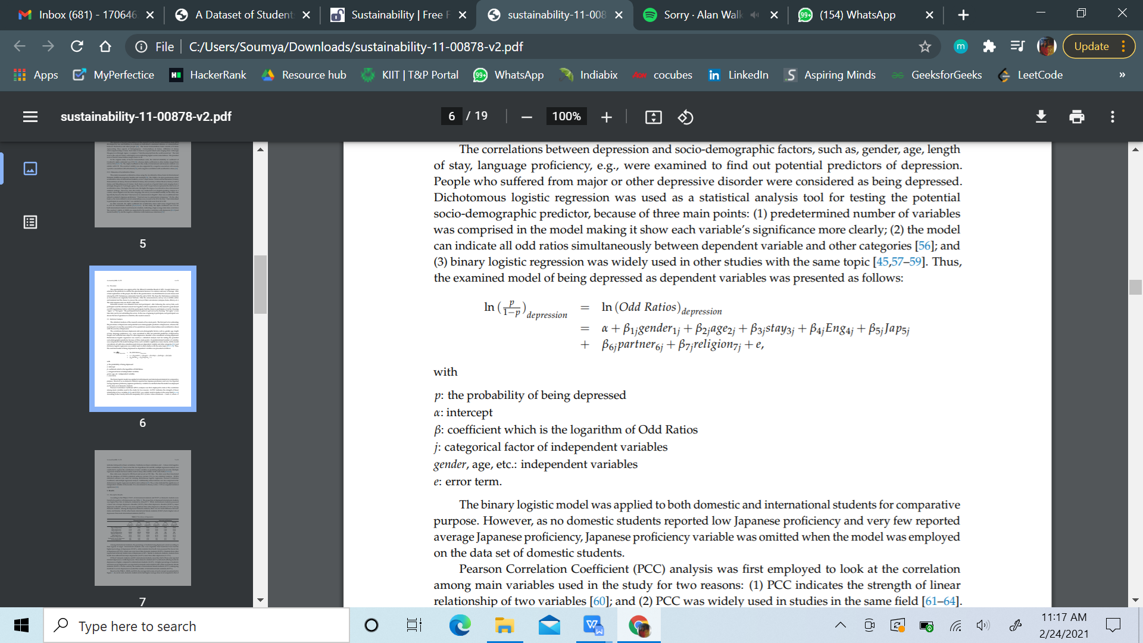

On the basis of the examined literature, the study seeks to answer the following research questions (RQ1 and RQ2) and hypotheses (H1 and H2) based on data collected from an international university in Japan:

RQ1: What is the prevalence of depression among domestic and international students?

RQ2: What are the socio-demographic predictors of depression among domestic and international students?

H1: Acculturative stress will be significantly positively associated with depression in both domestic and international students. Students in an international university were expected to have higher depression levels due to extensive conflicts during acculturation process.

H2: Social connectedness will be significantly negatively associated with depression in both domestic and international students. A greater sense of connectedness with others will make individual feel more comfortable and confident within a social context, which will prevent depression.

**PROS:**

1. This study found a positive correlation between acculturative stress and

depression among domestic and international students

**CONS:**

1. In the data collection process, the team used sampling and needed to modify the model questionnaire slightly.
2. In addition, findings were based on self-reported measures.

-Besides that, different proportions of students from different origins might cause the results to have a regional bias among the surveyed international students.

**CONCLUSION:**

In the cross-sectional questionnaire of 67 domestic students and 201 international students, the study found that 29.85% of domestic students and 37.81% of international students were positive to major depressive disorder or other depressive disorder. In addition, the findings also highlight several socio-demographic predictors (age, English proficiency, and length of stay) and main associations (social connectedness and acculturative stress) of depression.

**5.Vuong, Q. H., Vuong, T. T., Ho, T. M., & Nguyen, H. V. (2017). Psychological and socio-economic factors affecting social** **sustainability through impacts on perceived health care quality and public health: The case of Vietnam. *Sustainability*, *9*(8), 1456.**

A study on over 2000 patients has been conducted in Hanoi, Vietnam, to explore the influences of psychological and socio-economic factors on the evaluation of healthcare quality and public health by patients. The findings suggest effective health communication and the status of being married are two elements that have the strongest impact on people’s positive perceptions about healthcare quality . Young unmarried people and the insured tend to be more critical of healthcare quality. At the same time, a higher BMI and better view of health care quality are linked to negative opinions about community health. These outcomes suggest that in order to maintain collective health as part of social sustainability, the Vietnamese government should pay attention to infrastructure improvement, insurance system reforms, and communication of personal health care knowledge.

**METHOD:**

This study collected data on a range of socio-economic and demographic indicators. Participants were patients, chosen at random with no discriminatory criteria; response rates were approximately 83% (5 out of 6). The questions were direct and simple, and participants were instructed by the interviewer to ensure that each questionnaire

was filled correctly.Raw data was first recorded in Excel and then executed in R.To examine the impact of demographics, society and psychology on the patient’s evaluation of health care services quality, multivariate linear regression was used with the general model as follows:

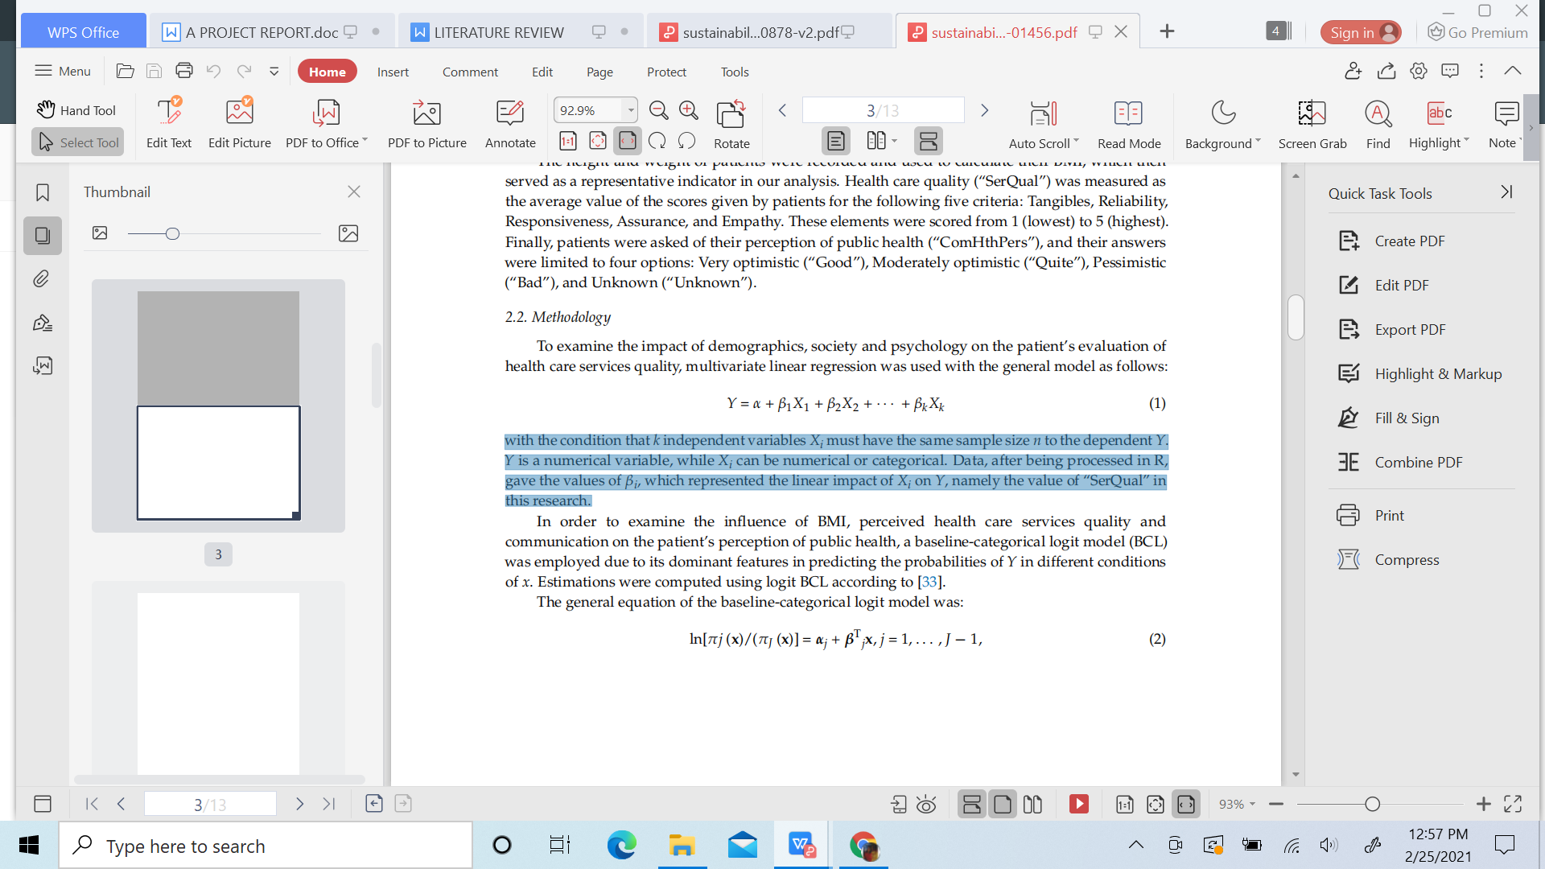

with the condition that *k* independent variables *Xi* must have the same sample size *n* to the dependent *Y*. *Y* is a numerical variable, while *Xi* can be numerical or categorical. Data, after being processed in R, gave the values of *βi* , which represented the linear impact of *Xi* on *Y*, namely the value of “SerQual” in this research.

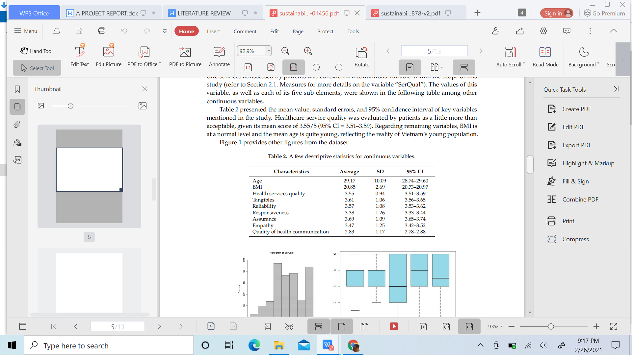

**PROS:**

1. When the quality of health communication rises, people receive

more information, both in quality and quantity; their assessment will be more informed and reasonable.

1. Family is the primary unit for health education in all countries, despite the country’s level of economic development.

**CONS:**

1. When someone is less healthy (represented the risk of being overweight,

in this case), they are more likely to project their own concerns on the rest of society, thus feeling pessimistic about the current state of community health.

**CONCLUSION:**

- It has been established that better access to health-related knowledge—whether via mass-media health communication or through first-hand or second-hand experiences with medical care from family and friends—positively influence a patient’s evaluation of health care service quality.

-People in better shape would have a more optimistic view of public health.

Most counter intuitively, it was discovered that favourable perceptions of heath care service quality are linked to a pessimistic view of public health, and vice versa.

